2.Concepts Of Frequency Distribution.

Frequency Distribution is a systematic arrangement of data into different classes or categories along with the number of observations (frequency) falling in each class.

Frequency distribution is a method of organizing and summarizing data to show the frequency (count) of each possible outcome of a dataset. It is an essential tool in statistics for understanding the distribution and pattern of data. There are several types of frequency distributions used based on the nature of the data and the analysis required.
It is not always possible for an investigator to easily measure the items of a series or set of data. To make the data simple and easy to read and analyze, the items of the series are placed within a range of values or limits

Need for Frequency Distribution

* Converts raw data into an organized form.
* Makes large data easy to understand.
* Helps in finding statistical measures like Mean, Median, and Mode.
* Facilitates comparison between datasets.
* Provides the basis for graphs such as histograms.

Frequency Distribution Examples
The marks of a class of 20 students are 11, 27, 18, 14, 28, 18, 2, 22, 11, 24, 22, 11, 8, 20, 25, 28, 30, 12, 11, 8. Prepare a frequency distribution table for the same.

Solution:
The range of marks of the students is 2- 28. Let us take class intervals 0-5, 5-10, 10-15, 15-20, 20-25, and 25-30.
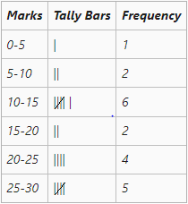

Types of Frequency Distribution

1. Individual Frequency Distribution

When in the classification each value is listed separately then this type is used.

| Marks | Frequency |

| ----- | --------- |

| 10 | 2 |

| 15 | 3 |

| 20 | 5 |

2. Discrete Frequency Distribution

Data consists of distinct values.

Example| No. of Children | Frequency |

| --------------- | --------- |

| 0 | 5 |

| 1 | 8 |

| 2 | 12 |

| 3 | 6 |

3. Continuous Frequency Distribution:

When the data is large then that data is grouped into class intervals for easy classification & presentation.

| Marks | Frequency |

| ----- | --------- |

| 0–10 | 4 |

| 10–20 | 7 |

| 20–30 | 12 |

| 30–40 | 10 |

Types of Classification.
The six different types of the Classification are as follows:
- Exclusive Classification.
- Inclusive Classification.
- Open End Classification.
- Cumulative Frequency Classification.
- Mid-Value Frequency Classification.
- Equal and Unequal Class Interval Classification.

Exclusive Series:
The series with class intervals, in which all the items having the range from the lower limit to the value just below its upper limit are included, is known as the Exclusive Series. This kind of frequency distribution is known as an exclusive series because the frequencies corresponding to the specific class interval do not include the value of its upper limit.
For example, if a class interval is 0-10, and the values of the given series are 4, 10, 2, 15, 8, and 9, then only 4, 2, 8, and 9 will be included in the 0-10 class interval. 10 and 15 will be included in the next class interval, i.e., 10-20. Also, the upper limit of a class interval is the lower limit of the next class interval.
Age | 0-10 | 10-20 | 20-30 | 30-40 | 40-50 | 50-60
No of Persons | 8 | 12 | 20 | 15 | 9 | 6

Case Study : Online Shopping Delivery Time (Exclusive Classification)

An e-commerce company studied the delivery time of online orders.

| Delivery Time (Days) | Number of Orders |
| -------------------- | ---------------: |
| 0–2 | 25 |
| 2–4 | 45 |
| 4–6 | 30 |
| 6–8 | 15 |
| 8–10 | 5 |

The company wants to improve customer satisfaction by reducing delivery delays.

Questions

1. Identify the type of classification.
2. Calculate the class width.
3. Calculate the class mark of each interval.
4. Which delivery-time interval has the highest number of orders?
5. If an order was delivered in exactly *4 days*, in which class will it be included?

Inclusive Series:
The series with class intervals, in which all the items having the range from the lower limit up to the upper limit are included, is known as Inclusive Series. Like exclusive series, the upper limit of one class interval does not repeat itself as the lower limit of the next class interval. Therefore, there is a gap (between 0.1 to 1) between the upper-class limit of one class interval and the lower limit of the next class interval.
For example, class intervals of an inclusive series can be, 0-9, 10-19, 20-29, 30-39, and so on. In this case, the gap between the upper limit of one class interval and the lower limit of the next class interval is 1, and the class intervals do not overlap with each other like in an exclusive series.

Age | 0-9 | 10-19 | 20-29 | 30-39 | 40-49 | 50-59
No of Persons | 8 | 12 | 20 | 15 | 9 | 6

Case Study : Theme Park Roller Coaster Waiting Time (Inclusive Classification)

A theme park recorded the waiting time (in minutes) for its most popular roller coaster.

| Waiting Time (Minutes) | Visitors |
| ---------------------- | -------: |
| 0–9 18 |
| 10–19 | 30 |
| 20–29 | 25 |
| 30–39 | 15 |
| 40–49 | 12 |

The park management wants to improve visitor experience.

Questions

1. Identify the classification method.
2. Find the class width.
3. Calculate the class mark for each interval.
4. During which waiting-time interval did the maximum number of visitors wait?
5. Suggest one strategy the park can use to reduce waiting time.

Open End Series
Sometimes the lower limit of the first class interval and the upper class limit of a series is not available; instead, Less than or Below is mentioned in the former case (in place of the lower limit of the first class interval), and More than or Above is mentioned in the latter case (in place of the upper limit of the last class interval). These types of series are known as Open End Series.

Age | Below 10 | 10-15 | 15-20 | 20-25 | 25-30 | 30 & Above
No of Persons | 8 | 12 | 20 | 15 | 9 | 6

Cumulative Frequency Series
A series whose frequencies are continuously added corresponding to the class intervals is known as Cumulative Frequency Series.
Conversion of a Simple Frequency Series into Cumulative Frequency Series
A simple frequency series can be converted into a cumulative frequency series. There are two ways through which it can be done. These are as follows:
- Expressing the cumulative frequencies on the basis of the upper limits of the class intervals. For example, expressing 10-20, 20-30, and 30-40 as Less than 20, Less than 30, and Less than 40.
- Expressing the cumulative frequencies on the basis of lower limits of the class intervals. For example, expressing 10-20, 20-30, and 30-40 as More than 20, More than 30, and More than 40.

Frequency Distribution in Cumulative Frequency Series
Convert the following simple frequency series into a cumulative frequency series using both ways.
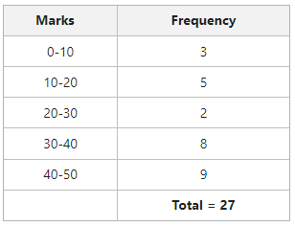

Solution:
Method-I (On the Basis of Upper Limits)
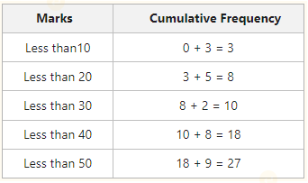

Mid-Value Frequency Series
The series in which, instead of class intervals, their mid-values are given with the corresponding frequencies, is known as Mid-Value Frequency Series.
Conversion of Mid-Value Frequency Series into Simple Frequency Series
The steps to convert a mid-value frequency series into a simple frequency series are as follows:
- The first step is to determine the mutual difference between the mid-values.
- The next step is to obtain half of the resulting difference.
- The last step of conversion is to subtract the resulting figure from the second step from the mid-value to get the lower limit of the class interval, and add the resulting figure from the second step to the mid-value to get the upper limit.
Lower Limit (l1)=m−12iLower Limit (l1​)=m−21​i
Upper Limit (l2)=m+12iUpper Limit (l2​)=m+21​i
m = Mid-Value
i = Difference between mid-values
l1=lower limitl1​=lower limit
l2=upper limitl2​=upper limit

Frequency Distribution in Mid-Value Frequency Series Example
Convert the following Mid-Value Frequency Series into Simple Frequency Series.
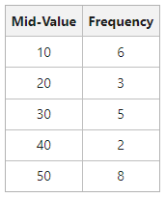

Solution:
